

# Project 2 Final Assessment

|  |  |  |  |
| --- | --- | --- | --- |
| **Faculty** | Information Technology | | |
| **Module Name** | Software Engineering | **Module Code** | ITSEA0 |
| **Project Number** | 2 | **Copy Editor** | Ms Nicole Stern |
| **Student Name** | Sopumelela | **Date Submitted** | 19/09/2023 |
| **Student Surname** | Sandekela | **Student Number** | CON-1475940-C5L6 |
| **Marker Name** |  | **Date Marked** |  |
| **Mark** | /100 | **Percentage** | % |
| **Moderator Name** |  | **Date Moderated** |  |
| **Mark** | /100 | **Percentage** | % |

|  |  |  |  |
| --- | --- | --- | --- |
| **Question Number** | | **Total** | **Mark Achieved** |
| Question 1 | | 100 |  |
| **Lecturer** |  | **Total Mark** |  |

ITSEA0 – **Project 2** – Final Assessment 2023 | V3.1 Page 1 of 10

Eduvos (Pty) Ltd. (formerly Pearson Institute of Higher Education) is registered with the Department of Higher Education and Training as a private higher education institution under the Higher Education Act, 101, of 1997. Registration Certificate number: 2001/HE07/008

# Question 1.1

## Actors

Actors and their specifications:

* **Customers:** These actors register into the system and get granted access to search for the DVDs and the video database. After the customer is done searching, he/she purchases the movie.
* **Regular customers:** These actors are part of the customers since they must register first and use the same payment system, now that they are regular, they use different searches to access the DVDs and the video database. Administrators give or cancel selling privileges to them.
* **System users:** These actors post DVDs or videos to be sold and have permission to add new movies to the database.
* **Administrators:** These actors will be administering the database and users; administrators are responsible for giving or cancelling selling privileges to regular customers
* **Sellers:** Communications via email or telephone to purchase or order products are made through these actors and in return they return an invoice upon successful payment.

ITSEA0 – **Project 2** – Final Assessment 2023 | V3.1 Page 2 of 10

# Question 1.2

## Used case

Use case for the system when the customer searches for a video and payment process:

* Register to the system.
* Permit access and search.
* Access permitted database.
* Access different databases.
* Search for a movie.
* Post DVDs.
* Post videos.
* Add new movies.
* Give selling privileges.
* Cancel selling privileges.
* Finish searching
* Purchase movie
* Remove from profile.
* Email invoice

ITSEA0 – **Project 2** – Final Assessment 2023 | V3.1 Page 3 of 10

# Question 1.3

Elaborate scenarios for the customers purchasing and searching a movie. These scenarios have Basic flow and Alternative path, according to Inflectra (2023: What to include in a Use Case, bullet 9 and bullet 10) <https://www.inflectra.com/Ideas/Topic/Use-Cases.aspx> (Accessed 15 Sept 2023) says Basic flow – also called the main success scenario, this is a use case path that works perfectly and as intended with no exceptions (this is often used as a base to create alternative paths). Alternative path (or flow) - a variation of the main success scenario, these usually show what happens when there’s an error or unexpected event in a use case.

**Customers Purchasing and Searching a movie**

Basic flow: Customer registers to the system with required information.

Alternative path: Customer information is somehow incorrect; the customer resubmits the information.

Basic flow: Customer use provided access to searches for DVDs and videos on the database.

Alternative path: Customer is a regular customer so uses different searches to access the DVDs and video database.

Basic flow: Customers finish searching for DVDs and video on database.

Alternative path: Customer cannot find the movie they are looking for; Customer ensure the spelling is correct and re-input the movie name.

Basic flow: Customers communicate with the seller via email or telephone to purchase.

Alternative path: customer decides not to buy movie and the process terminates.

Basic flow: Movie removed from that specific customer's profile in database.

Alternative path: Customer decides not to buy movie, so the movie is not removed.

Basic flow: An invoice emailed to the customer upon a successful payment.

Alternative path: The customer's payment is not successful, so the invoice is not emailed.

ITSEA0 – **Project 2** – Final Assessment 2023 | V3.1 Page 4 of 10

# Question 1.4

# Use case diagram documentation

# First of almost regular customer is a generalized actor of the customer Creately (2022: Generalization of an Actor) <https://creately.com/blog/diagrams/use-case-diagram-relationships> (Accessed 18 Sept 2023) states that Generalization of an actor means that one actor can inherit the role of the other actor and also states that the descendant has one or more use cases that are specific to that role.

# The customers register to the system, the administrators receive the information then permit access and search of the database to the customers. The customers access the permitted database while the regular customers access a different database. The customers search for a movie while the regular customers inherit the use case. The System users Post the DVDs or videos and add new movies. The administrators give or cancel selling privileges to regular customers.

# The Customers finish searching the database and purchases the movie to the seller while the regular customers inherit the use case. The administrator administers the database by removing the movie from that specific customer's profile. The seller emails the customer invoice upon a successful payment.

# 

A (.drawio) file named "Question 4 Use Case diagram" supporting the above image is found in the folder with the document.

ITSEA0 – **Project 2** – Final Assessment 2023 | V3.1 Page 5 of 10

# Question 1.5

# Customers go online and register if the information is incorrect the customer is requested to resubmit the info correctly. The administrator permits access and searching of the database to customers. The customer accesses the permitted database while the regular customer accesses the different database.

# The process of the administrator giving or cancelling selling privileges simultaneously happens with the process of the system users posting DVDs or videos and adding new movies. Customers search for movies if a movie is not found, the customers re-input the movie name and if found the customers communicate with the sellers. After communicating the movie is purchased and the process of emailing the invoice with removing the movie from specific profile happens simultaneously.

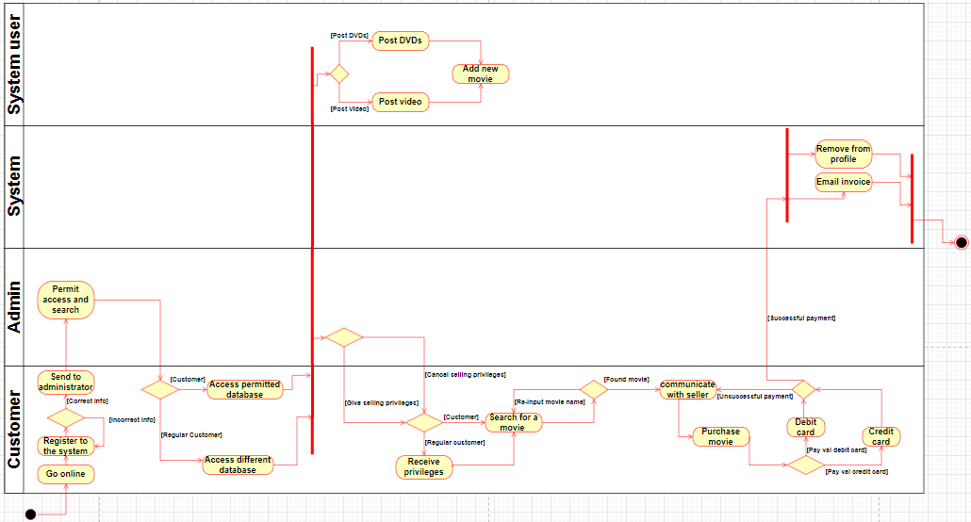

A (.drawio) file named "Question5 Activity diagram" supporting the above image is found in the folder with the document.

ITSEA0 – **Project 2** – Final Assessment 2023 | V3.1 Page 6 of 10

# Question 1.6

The Movie store system has five classes namely **Administrators, Customers, Regular customers, System users, Sellers**. Class usually has its name, attributes and operations according to IBM (2023: Attributes) <https://www.ibm.com/docs/en/dma?topic=classifiers-attributes> (Accessed 19/09/2023) saysattributes represent the information, data, or properties that belong to instances of a classifier. While according to Visual paradigm (2023: Class Operations (Methods)) <https://www.visual-paradigm.com/guide/uml-unified-modeling-language/uml-class-diagram-tutorial/> (Accessed 19/09/2023) say they are services the class provides.

From that I can describe the **Customers** class to have attributes of the customer's name, ID number, email address as they belong to the instance of the **Customers**. The sellers attribute has email address and telephone number used to communicate in order to purchase movie. With operations I can say **Customers** have operations of registering, accessing database, searching database, finish searching and purchasing movie while regular customers have a special operation of using a different database.

The **administrator's** operations are to permit access to database, give or cancel privilege and remove from profile. The **system user's** operations are to post DVDs or Videos and add new movies. The **Sellers** operations are to email invoice to a customer upon successful payment. 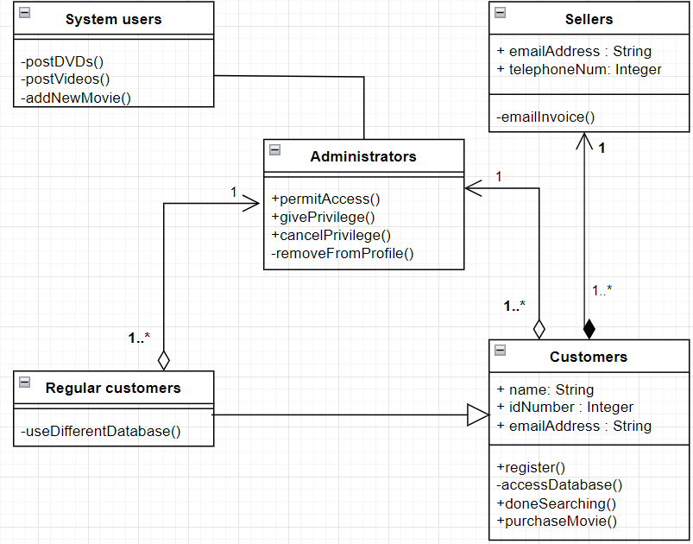

A (.drawio) file named "Question6 Class diagram" supporting the above image is found in the folder with the document.

ITSEA0 – **Project 2** – Final Assessment 2023 | V3.1 Page 7 of 10

# Question 1.7

# The Seller in order for the invoice to be created and payment need to be made. For that to happen the Customers make communication with the Seller, the receives the purchase request then sells the product to the Customers. The Customers purchase the product then the invoice is created, if there if unsuccessful payment the customer is requested to re-order again. The invoice is emailed to the Customers then the invoice is destroyed.

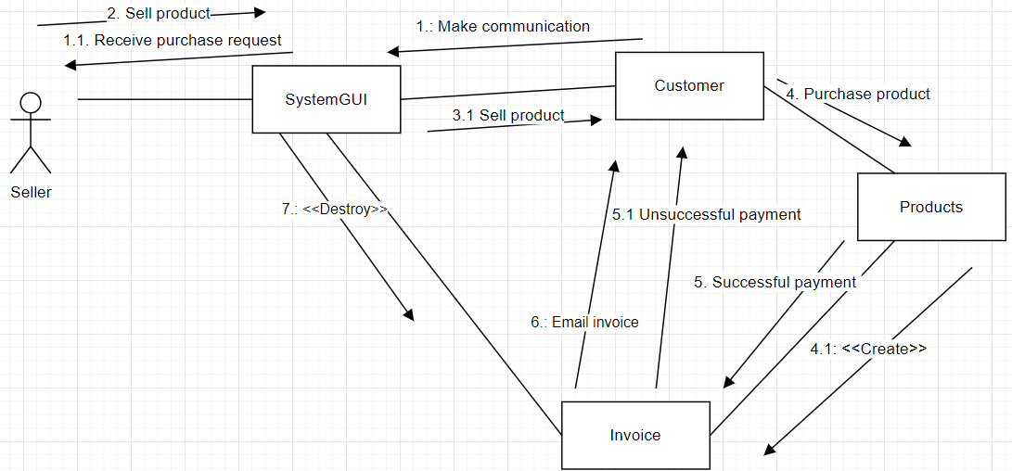

A (.drawio) file named "Question6 Class diagram" supporting the above image is found in the folder with the document.

# Question 1.8

The state machine diagram for the invoice class will focus on the on the state in which the object can be in during the purchasing process. For the invoice to be emailed to **Customers** the process needs to happen online, the payment is not expected to be always successful **Customers** are allowed to order again and buy the product.

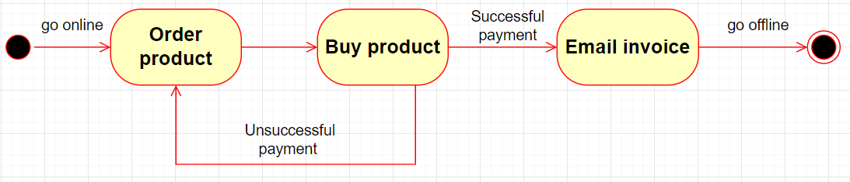

A (.drawio) file named "Question8 State machine diagram" supporting the above image is found in the folder with the document.

ITSEA0 – **Project 2** – Final Assessment 2023 | V3.1 Page 8 of 10

# Question 1.9

# Five software development methodologies

At the end of software planning and all the blueprints and analysis, the software needs to be developed to be implemented. I see this phase important as the others since it would not make sense to be able to do planning and analysis but fail to implement them when it comes to developing the software. On the I.T industry there are methodologies that have already been there for us to follow for strong and firm development that will be easy to develop according to what type of software and how big or small the company the software is made for. Another factor may be at which speed you want the development phase to take.

The following are five of available software development methodologies:

1. **Rapid Application Development (RAD):** This methodology may be self-explanatory from its name as it entails the word “Rapid”, this means this methodology has an element of the development happening at rapid speed. When anything this done quickly it has to be something small as it would cause misunderstanding if such were done on a huge scale. So, all in all this methodology might be mostly seen implemented on a small scale.
2. **Scrum methodology:** According to Amazon Web Services (2023: What is Scrum?) <https://aws.amazon.com/what-is/scrum/> (Accessed 19/09/2023) says scrum is a management framework that teams use to self-organize and work towards a common goal. This entails that for this methodology to be successful every member in the organization needs to be on the same page and encourage communication between each other.
3. **Feature-Driven Development (FDD):** This methodology may be also self-explanatory from its as it entails “feature-Driven”. This methodology seems to focus on the features of the application which are likely to be used by the client not that organization. With this methodology it would be safe to say that the development is driven by the satisfaction of the client to the application.
4. **Extreme Programming (XP):** This methodology has it on its name “extreme” as Kanbanzone (2023: What is the XP method in Agile?) <https://kanbanzone.com/resources/agile/extreme-programming-xp/> (Accessed 19/09/2023) says eXtreme Programming (XP) is an Agile methodology that takes software development to the extreme by truly embracing best practices while focusing on extreme quality and extreme responsiveness to changing customer requirements. This methodology is said to focus on small scale cycles at high speed which would create high quality.
5. Waterfall model: Waterfall model has it on its name as it is taken from the nature of the waterfall of it flowing towards one directing on a same sequence of motion. A waterfall is likely to be of huge scale of mountain cliff and changes are hard to be implemented after the development as it may disrupt the waterflow of the waterfall.

From all the above methodologies I would choose RapidApplication Development (RAD).

ITSEA0 – **Project 2** – Final Assessment 2023 | V3.1 Page 9 of 10

# Question 1.10

# I chose this methodology because I see Rapid Application Development (RAD) as a good methodology for this scenario as it is at a small scale and has the potential of being implemented at a bigger scale. Me and my team are more interested in rapid production to fight time and at the same time working on the quality of the system by that we would be meeting all the requirements we need and in the end all that matters is that the client is happy.

ITSEA0 – **Project 2** – Final Assessment 2023 | V3.1 Page 10 of 10